Bottleneck Experiment Paper - Figures

Jack Common

2/16/2018

Make sure all of the data files are in the same directory. Set this as your working directory in the R console. The directory I’ve put everything in to generate figures should be “OneDrive - University of Exeter/Data/Bottlenecks/paper figures”.

In the Rmd document, you will find a chunk that details all of the functions and graphing parameters used. Refer to this for details/edits

**Packages**

library(ggplot2)  
library(scales)  
library(reshape2)  
library(ggpubr)  
library(cowplot)  
library(knitr)

# Experiment 1: Culture & Phage Bottleneck

## Figure 2: Mean phage titer in each bottleneck treatment at each sampling point

I’m calling this Figure 2 for the time-being, but it may well end up as Figure 1. Change the code accordingly if this decision is made!

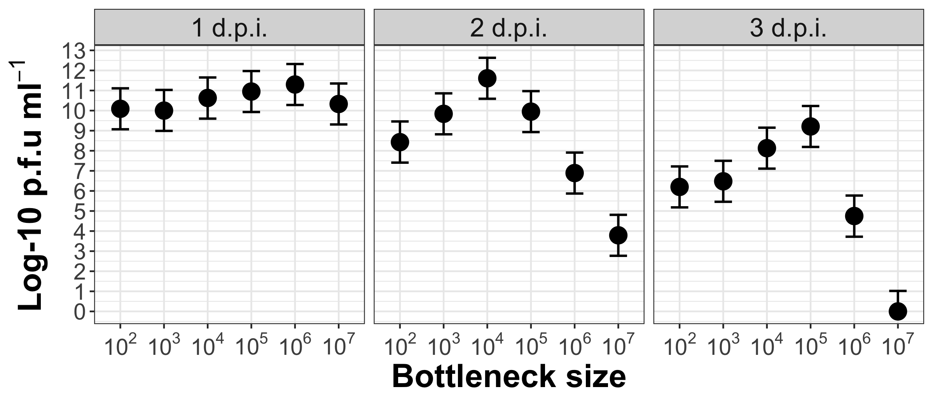

## Figure 3: Phenotypes, spacers and phage at t=3

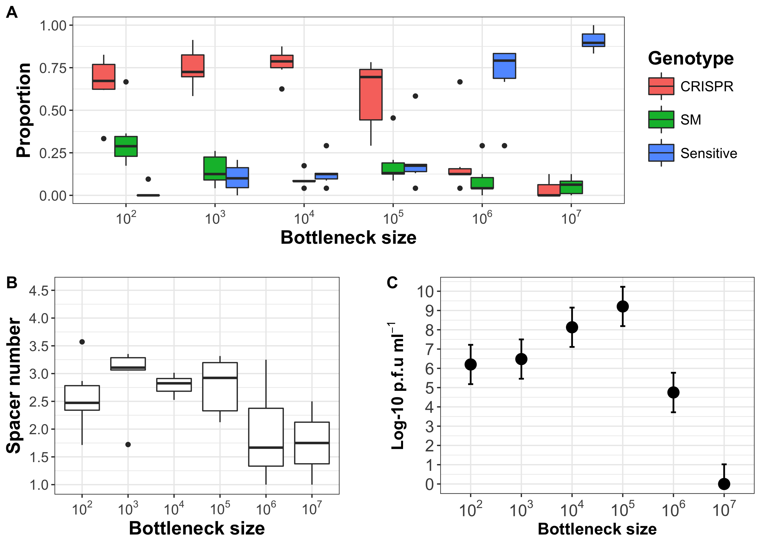

# Experiment 2: Culture Bottleneck

## Figure 4: Change in phage titers in each bottleneck treatment

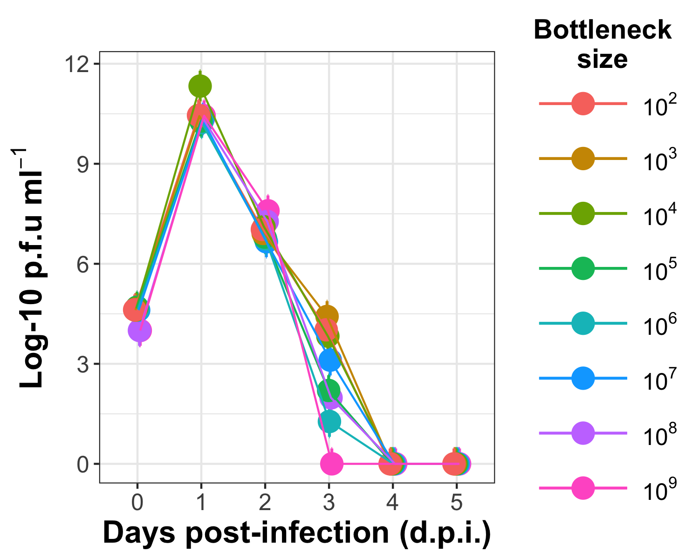

## Figure 5: Phenotype, spacers and phage at t=3

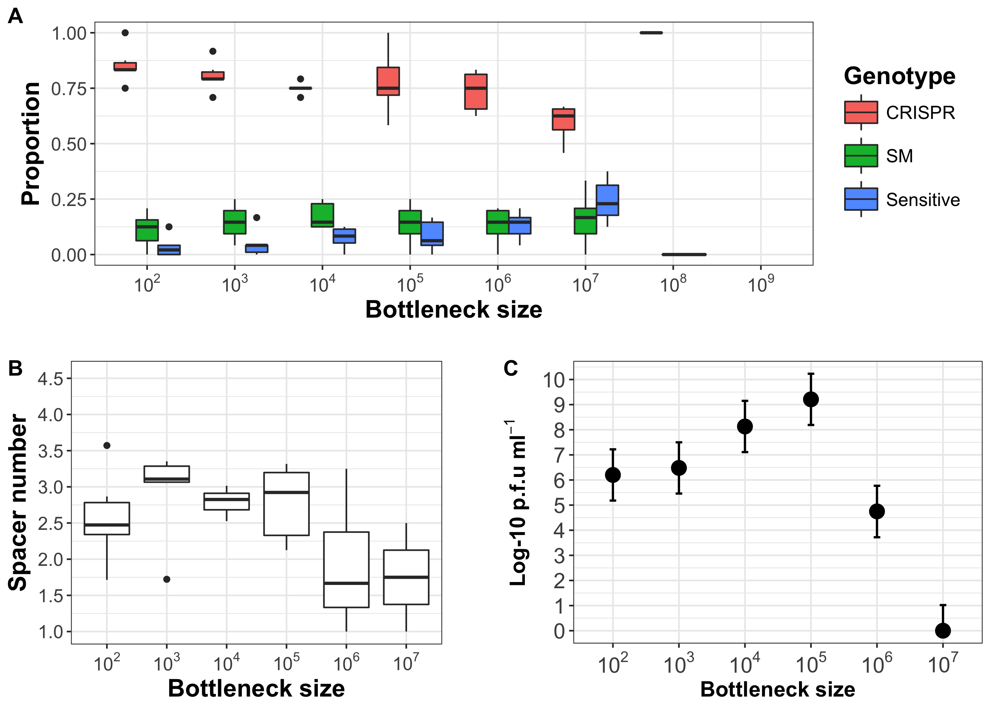

# Experiment 3

## Figure 6: Change in phage titers in each bottleneck treatment, by replicate

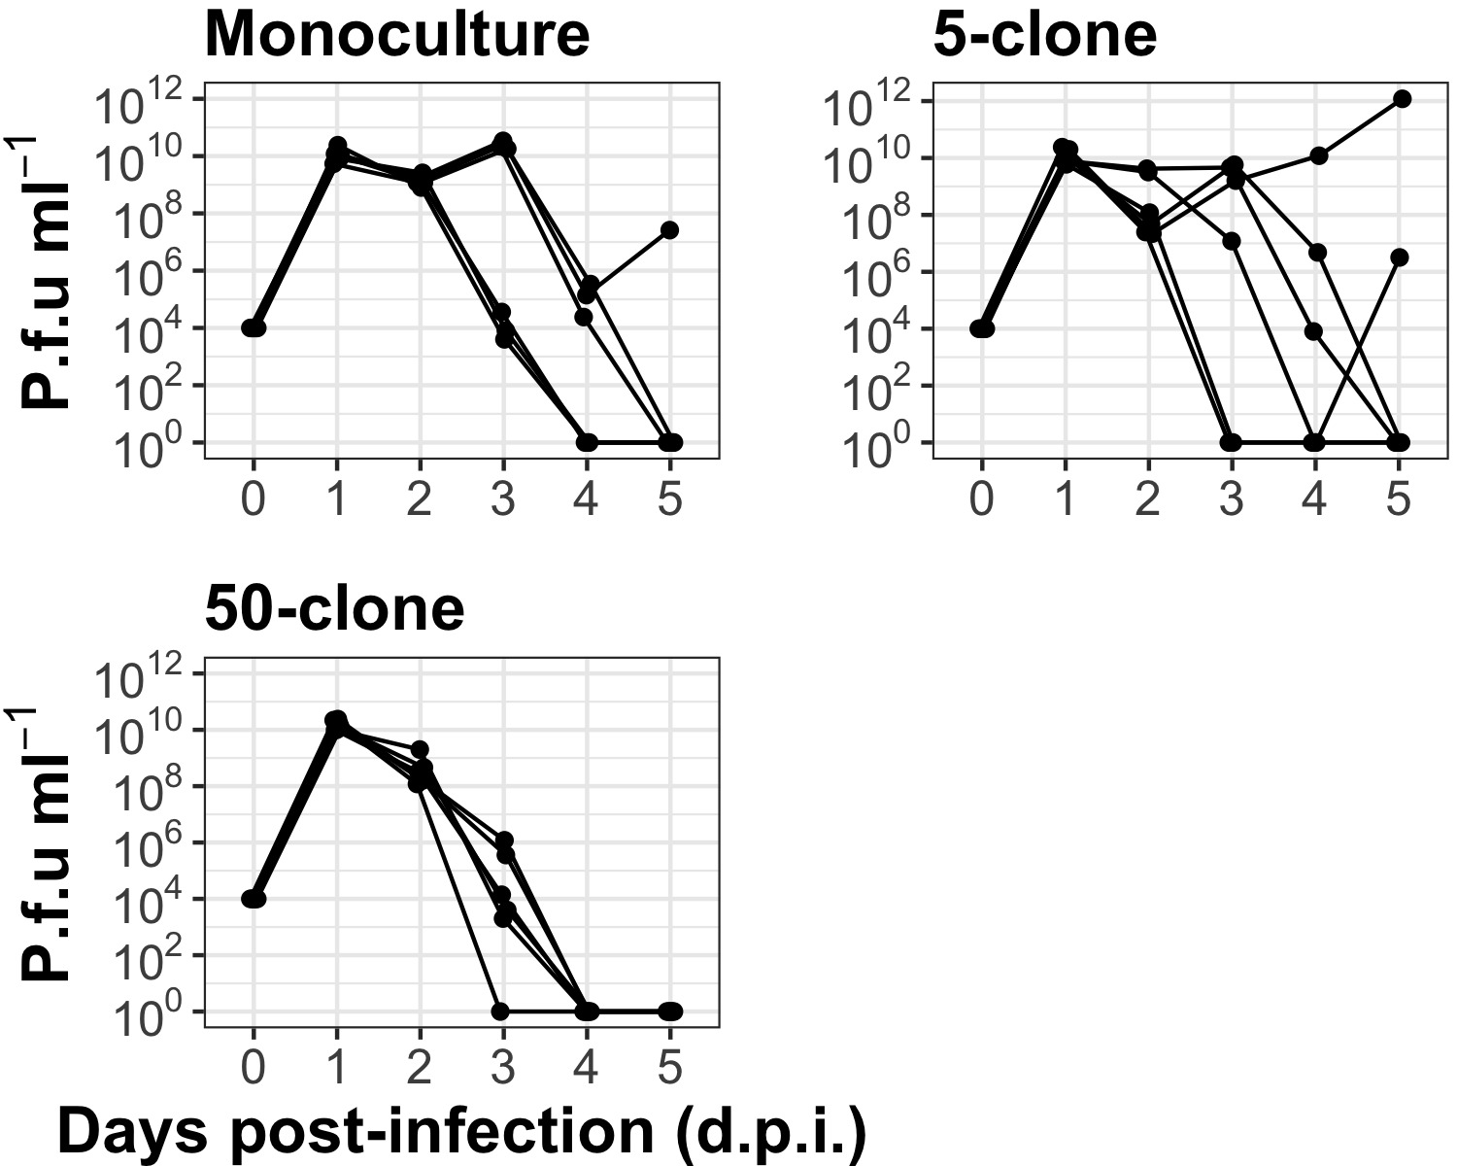

## Figure 7: Phenotype and spacers at t=3

